**phpMyAdmin Tutorial**

1. Open Browser -><http://localhost> and click on phpMyAdmin as shown below

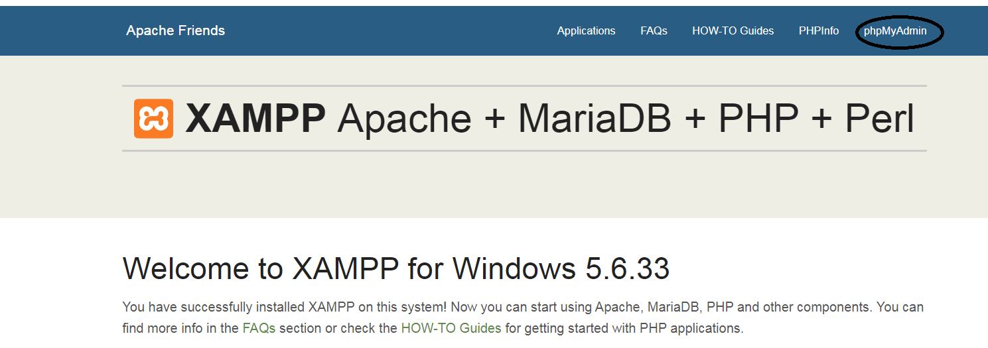

1. Click on Databases->Create database->Create mydb database

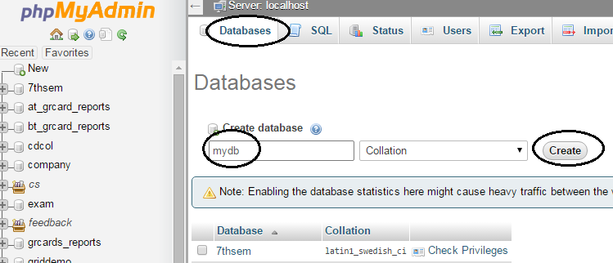

1. Click on Create table to create table stud1 inside mydb with 2 columns and click on-> Go

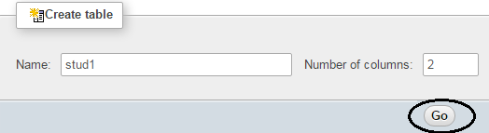

1. Create two attributes USN and Name and click on Save

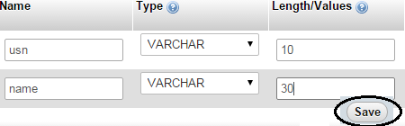

1. Click in Insert to insert data into the table.

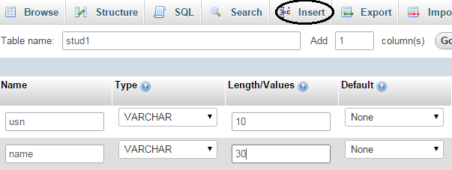

1. Enter two rows of data into the table and click on Go

